**Which smartwatch can we use our research?**

First of all, we use five factors of sensing values.

1. Heartbeat rate
2. Sound(microphone)
3. Location(GPS)
4. Time
5. Hand motion(accelerometer)

Below 3 smartwatches can monitor heartbeat and GPS.

I thought it would be possible to detect hand motion and sound by accelerometer and microphone

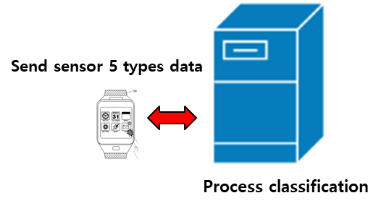

Figure 1 Overview system

Reference:

* <https://famisafe.wondershare.com/smartwatches/top-best-nfc-smart-watch.html>
* https://famisafe.wondershare.com/trackers/nike-gps-sport-watch.html

1. **Apple Watch Nike+ 42mm Silver Aluminium Case Nike Sport Band**

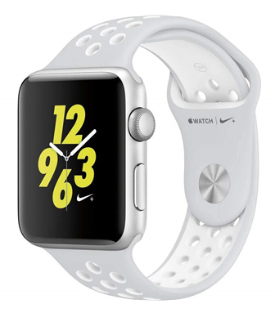

Amazon price: $389.94

Features

* Hard and highly durable metal aluminum case with an official Nike Sports band
* Built-in heart rate sensor for activity tracking
* Wi-Fi, Bluetooth, and integrated GPS connectivity
* Full compatibility with the Nike+ app

Pros

* Up to 18 hours of battery life
* Water resistant up to 50 meters
* Fantastic design with innovative user interface

Cons

* None!

1. **Nike SportWatch GPS Powered by TomTom (Blue Glow)**

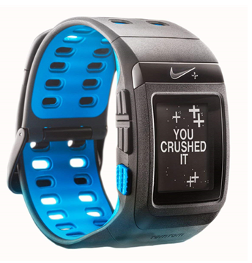

Amazon price: $270.75

Features

* Features TomTom GPS technology for the most accurate location and distance information
* Track all aspects of workout including speed, distance, pace, and heart rate
* A ton of motivational aspects including medals and awards

Pros

* Up to 50-days battery life on standby mode
* Join in challenges and share scores and activities via the Nike app
* Comes with a rechargeable battery and charger

Cons

* Not as durable as other watches
* Can experience issue with GPS website for updates

1. **Fitbit Versa:**

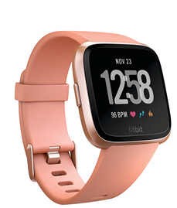

Amazon price: $199.95

Features:

* This is an NFC smartwatch with GPS and a heart rate monitor.
* It has all the main apps of a phone such as a calendar, text app, calling apps, etc.
* It has a 5-day battery life.

Pros:

* The watch is water resistant for 50 m.
* You can also download music without a phone.

Cons:

* The initial set up is a little bit time-consuming.

ECG, BPM Supports

Applce wach series 4 can support LTE · Wi-Fi · GPS, accelormeter(handmotion) gyroscope,BPM, ECG sensor

<http://www.itnews.or.kr/?p=29328>

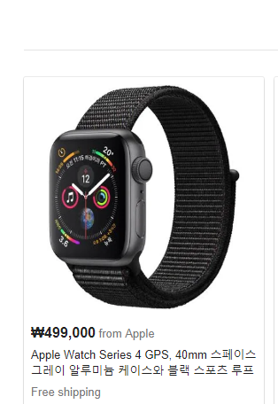

GSR Supports

**Microsoft Band 2**

It can support GSR (galvanic skin response) sensor, heart rate, GPS, accelormeter,

However, we have to use the Microsoft Band SDK for developing

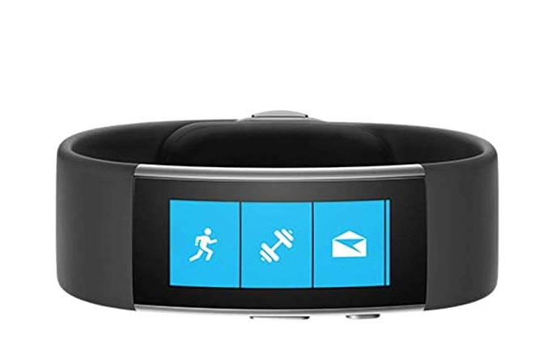

Price:  $249 (£200, AU$380